© Ericsson AB 2010
All rights reserved. The information in this document is the property of Ericsson. Except as specifically authorized in writing by Ericsson, the receiver of this document shall keep the information contained herein confidential and shall protect the same in whole or in part from disclosure and dissemination to third parties. Disclosure and disseminations to the receiver's employees shall only be made on a strict need to know basis. The information in this document is subject to change without notice and Ericsson assumes no responsibility for factual inaccuracies or typographical errors.

Abstract
This document named Mobilink IN Swap OSS Navigator HLD is part of the Establishment deliverables for the NSN IN Swap to Charging System 5.0 in Mobilink Pakistan.
Confidentiality Statement
The information in this document is designated as “Commercial in Confidence”. This is a Non-Disclosure Agreement meaning that it shall not be handed over to any party other than Ericsson and Mobilink Pakistan.
Disclaimer
This document is prone to amendments, improvements and corrections
subject to any information that may be missing, wrongly presented or where improvement is required and necessary.
Ericsson will be responsible for correcting mistakes and updating the document in case where information is incorrectly presented.

Document Approval
This document supports the Technical Requirement Specification of Charging System 5.0 for the NSN IN Swap project in Mobilink Pakistan. It is intended for scoping of the CS 5.0 project as well as guidance and reference purposes by Mobilink Pakistan and Ericsson project personnel. This document serves as the first version and will be updated periodically and when necessary and mutually agreed upon. Overall solution of the CS 5.0 will be based on this document.
Document Accepted by Mobilink Pakistan
Signature: __________________________
Name: __________________________
Date: __________________________

Document Accepted by Ericsson
Signature: __________________________
Name: __________________________
Date: __________________________

Contents
1 Revision History 6
2 Abbreviation &Terminology 6
3 Introduction 8
3.1 Purpose 8
4 Solution Overview 8
4.1 Overall Solution Setup 8
4.2 Operations Portal 10
5 Requirements for O&M Solution 10
5.1 Functional Requirements 10
5.2 Non-Functional Requirements 14
5.3 Target Integration specific requirements 15
6 OSS Navigator Solution Description 22
6.1 Hardware Configuration 23
6.2 Product Software Deliverables 24
6.3 Software Licenses 25
6.4 Fault Management 25
6.5 Performance Management 31
6.6 Configuration Management 35
6.7 Service Level Management 37
6.8 Performance Reports, Business Objects 40
7 References 52

Revision History

Date | Revision | Author | Comment
18/01/11 | PA1 | Mikael Mecklin | Initial draft
26/01/11 | PA2 | Mikael Mecklin | Updated document according to first review
31/01/11 | PA3 | Mikael Mecklin | Added BO PM reports
01/02/11 | PA4 | Mikael Mecklin | Added BO Report screenshots and descriptions
10/02/11 | PA5 | Mikael Mecklin | Added Requirements
25/03/11 | PB1 | Mikael Mecklin | Add chapter 6.8.1

Abstract: This document is created to outline the methods and procedures that will be employed to port the OSS Navigator into Mobilink’s Charging System.

Abbreviation &Terminology
The following table provides a list of abbreviations and terminologies used within the document.
Term | Description
BNSI | Basic Network Surveillance Interface
BO | Business Objects
CS | Charging System
CM | Configuration Management
ESM | Ericsson Surveillance Manager
FM | Fault Management
IA | Impact Analysis
IRP | Integration Reference Point
KPI | Key Performance Indicator
MIB | Management Information Base
NMS | Network Management System
PM | Performance Management
RCA | Root Cause Analysis
SLM | Service Level Management
SNF | Service Network Format
SNMP | Simple Network Management Protocol
SQM | Service Quality Monitoring
TXF | TMOS Text File

Introduction
This document describes the O&M high level solution design for the proposed management system for the monitoring of the Charging System 5.0 and the Multi Mediation nodes in Mobilink’s network. The management system that is to be implemented for this is based on Ericsson OSS Navigator, a product that has been designed specifically to support operation and maintenance if monitor service layer and IP nodes.

Purpose
This document has been prepared to provide clarity in the overall design for the implementation of the Ericsson Navigator O&M solution for the Charging System 5.0 and the Mediation nodes for Mobilink.

Solution Overview
The solution for Mobilink for management of their Charging System 5.0 and the Mediation nodes is based on two system components, OSS Navigator 1.2 and Business Objects Enterprise XI 3. Together they provide features, functions and capabilities to manage very large scale telecom network and services environment, where service availability and Quality of Service are mission critical.
In addition to these systems the solution also contains a common centralized backup management solution based on the Netbackup. The backup solution is covered in separate Solution Description document

Overall Solution Setup
All three solution components are complementing each other to provide customer good overall understanding of current network status. OSS Navigator Portal will be used as common reference point to access OSS Navigator applications and see most important reports and statistics. Customer has full control on the Portal configuration so the layout and startup options are fully customizable.

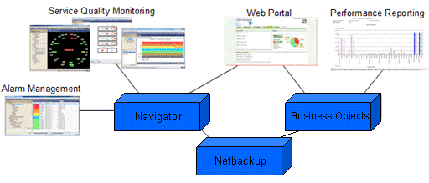
Figure 1 Overall solution components

The OSS Navigator will provide Network and Service monitoring capabilities for the CS5.0/Mediation nodes. Alarms and key performance data are collected, processed and any Service and Business impact is presented. It provides Service Impact Analysis (incl. alarm correlation) to better understand alarms from the infrastructure. This is especially useful in the case of infrastructure redundancy, multiple equipment and dependencies in the service delivery chain, and where talkative nodes generate large volume of low-value alarm messages. Service alarms are only raised if certain criteria are met.
Different users may have different criteria, for example Network Operation need to understand when the infrastructure does not perform as expected or is broken, Customer Care need to know when the end-user is impacted. These criteria can be configured via the GUI.
Together with the Business Objects reporting tools, the OSS Navigator solution will provide full PM statistics. OSS Navigator will handle the loading, aggregation and storing of the PM data whereas the Business Objects will be used for presenting the data in reports for the users. The reports part of the PM solution will be fully customized for Mobilink. The solution will be delivered with predefined customized reports and also the necessary universes for the reports.
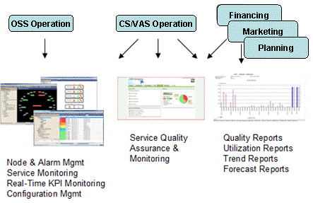
Figure 2 User Interaction with Management Solution

Operations Portal
The solution includes an Enterprise Portal primarily as part of the OSS Navigator solution. This portal is a common interface to the management solution and will as such provide the following functionality via the Web interface:
- Operations View - Alarm summary overview and alarm list
- Service Status View – Current state of Services
- Quality of Service View – Service Quality Indicators using real-time KPIs.
- Access to BO reporting Web GUI

Requirements for O&M Solution

Functional Requirements

Fault Management
REQ_OSS_01.01 System shall receive and collect incoming SNMP alarms from integrated nodes.
This is covered by the ESM component, for details please refer to chapter 6.4.2.
REQ_OSS_01.02 System shall receive and collect incoming TXF based alarms from integrated nodes.
This is covered by the ESM component, for details please refer to chapter 6.4.2.
REQ_OSS_01.03 System shall alert incoming alarms through User GUI.
This is covered by the MO (Managed Object) GUI in the Navigator solution.
REQ_OSS_01.04 System shall correlate incoming alarms when possible with previously received alarms
This is covered by the ESM component, for details please refer to chapter 6.4.2.
REQ_OSS_01.05 System shall transform alarms into readable view using the set of predefined rules.
This is covered by the ESM component, for details please refer to chapter 6.4.2.
REQ_OSS_01.06 System shall monitor node connectivity and indicate alarm status through user GUI.
An availability object will be included in the topology for all integrated nodes. The object will show the status of connectivity.
REQ_OSS_01.07 Alarm list shall be accessible via web interface
Alarms list is available in the myNavigator, for details see chapter 6.7.4.
REQ_OSS_01.08 System shall be capable of handling up to a total of
100,000 open alarms
This is covered by the characteristics of the OSS Navigator product. For details of the characteristics please see ref. [5]

Performance Management
REQ_OSS_01.09 System shall gather the data for performance measurement published in MIBs through SNMP interface and collect it in it’s database
Covered by ESM, please see chapter 6.5.1 for details.
REQ_OSS_01.10 System shall gather the data for performance measurement stored in files in CSV or XML format and collect it in it’s database.
Covered by ESM, please see chapter 6.5.16.5.2 for details.
REQ_OSS_01.11 System shall provide an interface for modification of existing or creating new performance reports.
This is covered by Web Intelligence Rich Client which is included in the Business Objects environment. Web Intelligence Rich Client is an application for creating, editing, refreshing and publishing Web Intelligence documents (.wid) in Business Objects Enterprise XI 3
REQ_OSS_01.12 System shall provide an interface to Business objects portal acting as performance report visualization tools
InfoView in the Business Objects environment provides a web based interface for the reports.

Configuration Management
REQ_OSS_01.13 System shall provide the interface to configure specific commands could be send to integrated systems
Operational Task is a functionality in the OSS Navigator Client to enable execution of commands towards the network. These commands can be selected from the OSS Navigator Client GUI. The Operation Tasks are defined in the topology xml file for the managed nodes.

Reporting and Statistics
REQ_OSS_01.14 System shall provide a tool for visualization and reporting of collected data.
This is covered by the MO and BO tools that are included in the solution.
REQ_OSS_01.15 System shall provide a web based interface for accessing the reports
Covered by the BO solution which is part of the OSS Navigator solution.
REQ_OSS_01.16 Ericsson shall provide predefined, with a maximum of 10, Business Objects PM reports for the CS nodes that the OSS system collects measurement data from. Customer specific BO reports requirements have to be agreed together with Mobilink.
Predefined reported will developed during the project, for list of the reports please see chapter 6.8.

System modeling
REQ_OSS_01.17 System shall provide a possibility to define logical model of managed nodes (network topology).
Covered by the ESM topology, this is described in chapter 6.4.1.
REQ_OSS_01.18 System shall provide a possibility to group nodes and build hierarchical relationships between the nodes.
Covered by the ESM topology, this is described in chapter 6.4.1 and the modeling functionality in MO.
REQ_OSS_01.19 Systems shall provide a possibility to map incoming alarms to nodes and process manually defined in the logical network model.
The alarms will be mapped to the topology based on predefined rules.

Non-Functional Requirements

Performance
REQ_OSS_02.01 OSS system shall be capable of handling 250 integrated nodes.
This is covered by the characteristics of the OSS Navigator product. For details of the characteristics please see ref. [5]
REQ_OSS_02.02 OSS system shall be capable of serving 30 simultaneously users.
This is covered by the characteristics of the OSS Navigator product. For details of the characteristics please see ref. [5]

Logging
REQ_OSS_02.03 All alarms that are unidentified should be logged.
Alarms that are received from unmanaged nodes will be dropped but logged in the ESM log. Unidentified alarms from managed nodes will be displayed in the alarm list in raw format and also logged in the ESM log.

Documentation
REQ_OSS_02.03 Ericsson shall provide all product and solution customized documentation. The list of delivered documentation should be specified.
Documentation of the OSS Navigator solution will be delivered during the project.

External Interfaces
REQ_OSS_02.03 System shall provide a northbound interface for forwarding of alarms.
OSS Navigator provides a BNSI Northbound interface, see chapter 6.4.4.

Target Integration specific requirements

AIR/AF
REQ_OSS_03.01 OSS system shall be integrated towards all AIR/AF node(s) in the CS 5.0 solution
All nodes will be integrates as defined in chapters 6.4.3, 6.5.6 and 6.6
REQ_OSS_03.02 OSS system shall be capable of receiving and handling the alarms and events sent by the AIR system(s).
This will be covered by the TXF integration as described in chapter 6.4.3
REQ_OSS_03.03 The OSS system shall collect and store the performance measurements that are produced by the node
PM data (xml) files that are produced by the node will be collected by OSS navigator and loaded into the PM database. See also chapter 6.5.6
REQ_OSS_03.04 The node measurement data shall be accessible from the Navigator GUI (MO), PM Reporting tool and via SQL interface
PM data will be available in MO through the CS PM adapter. Node PM will also be fetched to the BO and PM database have a SQL interface (Sybase isql)
REQ_OSS_03.05 It shall be possible to launch node GUI application(s), if such tool(s) provided by the node, and node CLI from the OSS GUI
Predefined Operational Tasks will be defined for the node topology. This is described in chapter 6.6

CCN
REQ_OSS_03.06 OSS system shall be integrated towards all CCN node(s) in the CS 5.0 solution
All nodes will be integrates as defined in chapters 6.4.3, 6.5.6 and 6.6
REQ_OSS_03.07 OSS system shall be capable of receiving and handling the alarms and events sent by the CCN system(s).
This will be covered by the SNMP (IRP) integration as described in chapter 6.4.3
REQ_OSS_03.08 The OSS system shall collect and store the performance measurements that are produced by the node
PM data (xml) files that are produced by the node will be collected by OSS navigator and loaded into the PM database. See also chapter 6.5.6
REQ_OSS_03.09 The node measurement data shall be accessible from the Navigator GUI (MO), PM Reporting tool and via SQL interface
PM data will be available in MO through the CS PM adapter. Node PM will also be fetched to the BO and PM database have a SQL interface (Sybase isql)
REQ_OSS_03.10 It shall be possible to launch node GUI application(s), if such tool(s) provided by the node, and node CLI from the OSS GUI
Predefined Operational Tasks will be defined for the node topology. This is described in chapter 6.6

CRS
REQ_OSS_03.11 OSS system shall be integrated towards all CRS node(s) in the CS 5.0 solution
All nodes will be integrates as defined in chapters 6.4.3, 6.5.6 and 6.6
REQ_OSS_03.12 OSS system shall be capable of receiving and handling the alarms and events sent by the CRS system.
This will be covered by the TXF integration as described in chapter 6.4.3
REQ_OSS_03.13 The OSS system shall collect and store the performance measurements that are produced by the node
PM data (xml) files that are produced by the node will be collected by OSS navigator and loaded into the PM database. See also chapter 6.5.6
REQ_OSS_03.14 The node measurement data shall be accessible from the Navigator GUI (MO), PM Reporting tool and via SQL interface
PM data will be available in MO through the CS PM adapter. Node PM will also be fetched to the BO and PM database have a SQL interface (Sybase isql)
REQ_OSS_03.15 It shall be possible to launch node GUI application(s), if such tool(s) provided by the node, and node CLI from the OSS GUI
Predefined Operational Tasks will be defined for the node topology. This is described in chapter 6.6

IVR/VXML
REQ_OSS_03.16 OSS system shall be integrated towards all IVR/VXML node(s) in the CS 5.0 solution
All nodes will be integrates as defined in chapters 6.4.3, 6.5.6 and 6.6
REQ_OSS_03.17 OSS system shall be capable of receiving and handling the alarms and events sent by the IVR node(s).
This will be covered by the SNMP (MST) integration as described in chapter 6.4.3
REQ_OSS_03.18 The OSS system shall collect and store the performance measurements that are produced by the node
PM data (xml) files that are produced by the node will be collected by OSS navigator and loaded into the PM database. See also chapter 6.5.6
REQ_OSS_03.19 The node measurement data shall be accessible from the Navigator GUI (MO), PM Reporting tool and via SQL interface
PM data will be available in MO through the CS PM adapter. Node PM will also be fetched to the BO and PM database have a SQL interface (Sybase isql)

REQ_OSS_03.20 It shall be possible to launch node GUI application(s), if such tool(s) provided by the node, and node CLI from the OSS GUI
Predefined Operational Tasks will be defined for the node topology. This is described in chapter 6.6

MINSAT
REQ_OSS_03.21 OSS system shall be integrated towards all MINSAT node(s) in the CS 5.0 solution
All nodes will be integrates as defined in chapters 6.4.3, 6.5.6 and 6.6
REQ_OSS_03.22 OSS system shall be capable of receiving and handling the alarms and events sent by the MINSAT node(s).
This will be covered by the TXF integration as described in chapter 6.4.3
REQ_OSS_03.23 The OSS system shall collect and store the resource indicator performance measurements that are produced by the node
PM data (xml) files that are produced by the node will be collected by OSS navigator and loaded into the PM database. See also chapter 6.5.6
REQ_OSS_03.24 The node measurement data shall be accessible from the Navigator GUI (MO), PM Reporting tool and via SQL interface
PM data will be available in MO through the CS PM adapter. Node PM will also be fetched to the BO and PM database have a SQL interface (Sybase isql)
REQ_OSS_03.25 It shall be possible to launch node GUI application(s), if such tool(s) provided by the node, and node CLI from the OSS GUI
Predefined Operational Tasks will be defined for the node topology. This is described in chapter 6.6

SDP
REQ_OSS_03.26 OSS system shall be integrated towards all SDP node(s) in the CS 5.0 solution
All nodes will be integrates as defined in chapters 6.4.3, 6.5.6 and 6.6
REQ_OSS_03.27 OSS system shall be capable of receiving and handling the alarms and events sent by the SDP system.
This will be covered by the TXF integration as described in chapter 6.4.3
REQ_OSS_03.28 The OSS system shall collect and store the resource indicator performance measurements that are produced by the node
PM data (xml) files that are produced by the node will be collected by OSS navigator and loaded into the PM database. See also chapter 6.5.6
REQ_OSS_03.29 The node measurement data shall be accessible from the Navigator GUI (MO), PM Reporting tool and via SQL interface
PM data will be available in MO through the CS PM adapter. Node PM will also be fetched to the BO and PM database have a SQL interface (Sybase isql)
REQ_OSS_03.30 It shall be possible to launch node GUI application(s), if such tool(s) provided by the node, and node CLI from the OSS GUI
Predefined Operational Tasks will be defined for the node topology. This is described in chapter 6.6

SunMC
REQ_OSS_03.31 OSS system shall be integrated towards all SunMC node(s) in the CS 5.0 solution
All nodes will be integrates as defined in chapters 6.4.3, 6.5.6 and 6.6
REQ_OSS_03.32 OSS system shall be capable of receiving and handling the alarms and events sent by the SunMC node(s).
This will be covered by the TXF or SNMP integration as described in chapter 6.4.3

EMM File & Event
REQ_OSS_03.33 OSS system shall be integrated towards all EMM (F&E) node(s) in the CS 5.0 solution
All nodes will be integrates as defined in chapters 6.4.3, 6.5.6 and 6.6
REQ_OSS_03.34 OSS system shall be capable of receiving and handling the alarms and events sent by the EMM FE system.
This will be covered by the SNMP (MST) integration as described in chapter 6.4.3
REQ_OSS_03.35 The OSS system shall collect and store the resource indicator performance measurements that are produced by the node
PM data (xml) files that are produced by the node will be collected by OSS navigator and loaded into the PM database. See also chapter 6.5.6
REQ_OSS_03.36 The node measurement data shall be accessible from the Navigator GUI (MO), PM Reporting tool and via SQL interface
PM data will be available in MO through the CS PM adapter. Node PM will also be fetched to the BO and PM database have a SQL interface (Sybase isql)

EMM Online Gateway
REQ_OSS_03.37 OSS system shall be integrated towards all EMM (Online mediation) node(s) in the CS 5.0 solution
All nodes will be integrates as defined in chapters 6.4.3, 6.5.6 and 6.6
REQ_OSS_03.38 OSS system shall be capable of receiving and handling the alarms and events sent by the EMM Online system(s).
This will be covered by the SNMP (MST) integration as described in chapter 6.4.3
REQ_OSS_03.40 The OSS system shall collect and store the resource indicator performance measurements that are produced by the node
PM data (xml) files that are produced by the node will be collected by OSS navigator and loaded into the PM database. See also chapter 6.5.6
REQ_OSS_03.41 The node measurement data shall be accessible from the Navigator GUI (MO), PM Reporting tool and via SQL interface
PM data will be available in MO through the CS PM adapter. Node PM will also be fetched to the BO and PM database have a SQL interface (Sybase isql)

Charging System 5.0 Service Model
REQ_OSS_03.42 Ericsson shall provide a predefined service model for the Charging solution
Covered by the CS 5.0 Service Model, see chapter 6.7.1
REQ_OSS_03.43 The following services models shall be predefined:
- CDR Handling
- Charging Services
- User Services
- Provisioning Services
Covered by the CS 5.0 Service Model, see chapter 6.7.1
REQ_OSS_03.44 The Service Model shall have predefined KPIs defined
Covered by the CS 5.0 Service Model, see chapter 6.7.1

OSS Navigator Solution Description
The Service Network Management solution is based on Ericsson OSS Navigator. This system is the primary selection from Ericsson for supporting centralized operation and maintenance for service networks in terms of
- Fault Management (FM)
- Performance Management (PM)
- Configuration Management (CM)
- Service Management (SM)
The offered OSS Navigator will provide Network and Service monitoring capabilities for the CS5.0 and related Mediation nodes. Alarms and Key Performance data are collected and processed in order to present Service and Business impact.
OSS Navigator will include herein classical Event management capabilities, i.e. all events/alarms are collected, stored and displayed. SNMP traps are managed by the ESM component (Ericsson Surveillance Manager). This proven system component has been extended to also include Text (TXF) based alarms, in order to support the management of Charging System nodes where this alarm interface is commonly used.
OSS Navigator provides Service Impact Analysis (incl. alarm correlation) to better understand alarms from the infrastructure. This is especially useful in the case of infrastructure redundancy, multiple equipment and dependencies in the service delivery chain, and where talkative nodes generate large volume of low-value alarm messages. Service alarms are only raised if certain criteria are met.
With the OSS Navigator it is also possible to monitor services, such as system services and end-user services, within a network. The services are represented by a logical model using the physical network entities, which means that the service model holds the relationship between a service and the network entities as well as the relationship between services.
Different users may have different criteria, for example Network Operation need to understand when the infrastructure does not perform as expected or is broken, Customer Care need to know when the end-user is impacted. Different user categories have their customized views configured via the GUIs and using the Web Portal.
OSS Navigator also allows for centralized configuration management (CM) by means of remotely launch and access network/service nodes and their in-built functionality of element management (EM) applications and command line interfaces (CLI).

Hardware Configuration

OSS Navigator
OSS Navigator server is running on a SunFire x4640 server. The server is equipped with four six-core CPUs out of a maximum of 8. It has a total of 128Gb of memory, which can be extended to a maximum of 512Gb.
The system is attached to a Sun 2540 Disk Array.
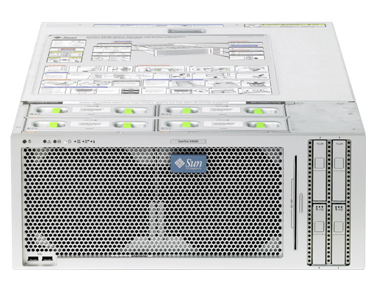
Figure 3 OSS Navigator Server
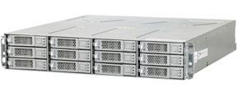
Figure 4 OSS Navigator Disk Array

Business Objects Server, BIS
The BO (Business Objects) server, which is used for PM reporting, is based on the on the X4250 HW
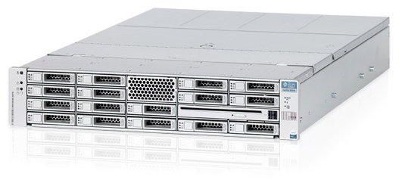
Figure 5 Business Objects Server
It comes equipped with:
- One Quad-core 2.13GHz CPU
- 4GB RAM
- 4 x 300 GB disk drives

Product Software Deliverables
The solution is based on Navigator 1.2 FP1.

Software Licenses
The Navigator Starter package has a license connected to the hardware configuration of the system.
Apart from the mandatory starter package the optional software modules Service MyNavigator and Navigator Dashboard is included in the solution.
The CS 5.0 node integrations are covered by the optional feature Charging System Tech Pack. Additional nodes to manage are licensed as right to connect according to a Tier concept. The Mediation nodes are covered with the optional OSS Navigator Tier 2 licenses and the SunMC and HXC nodes with the Tier 1 license.
The required license(s) for the 3PP product Business Objects is included in the optional RGBO-E feature.

Number | Description | Qty | Licensed per
FAJ 121 1243 | OSS Navigator Full Large Starter Package ( per CPU Socket ) | 1 | Server
FAJ 121 1252 | OSS Nav. Charging System Tech Pack | 14 | Node (CCN)
FAJ 121 1438 | MyNavigator | 1 | Server
FAJ 121 1245 | Navigator Dashboard | 1 | Server
FAJ 121 1259 | Connection to OSS Navigator Tier 1 | 12 | Node
FAJ 121 1259 | Connection to OSS Navigator Tier 2 | 2 | Node
FAJ 121 520 | Report Generator Business Objects Extension (RGBO-E), Additional developers in step of 25 | 1 | Server
Table 1 OSS Navigator licenses

Fault Management
There are different ways to integrate Fault Management of network elements in OSS Navigator.
The component in OSS Navigator implementing this functionality is named Ericsson Surveillance Manager (ESM) and has support for the following formats using SNMP.
- Service Network Format (SNF) MIB
- Ericsson IRP (IRP) MIB
- Any published SNMP MIB (MST)
In addition to these ESM implements support for alarms in text file format, i.e. Ericsson TXF, which is commonly used by Ericsson Service network elements.

Ericsson Surveillance Manager

SNMP SNF
SNMP IRP
SNMP MST
Network
Elements
TXF
Translations
Alarm
Forwarding
Figure 6 Alarm/Event Integration Architecture

The following operations are supported on all ESM alarms.
- Alarm Acknowledgmenet
- Alarm Un-acknowledgmenet
- Alarm Delete
The operations are logged by ESM in terms of user and time of the operation performed.
It is possible to store historical alarms in the OSS Navigator database.

System Topology
Every node type integrated in ESM is associated with a System Topology.
The System Topology defines the logical structure of the node and how alarms are connected to the functionality of the node. Each of the elements corresponds to a functional entity of the node and is used to represent the state of that entity.
The purpose of the System Topology is to represent the state of the node in a more clear way and to simplify the mapping of functional entities in the service model.
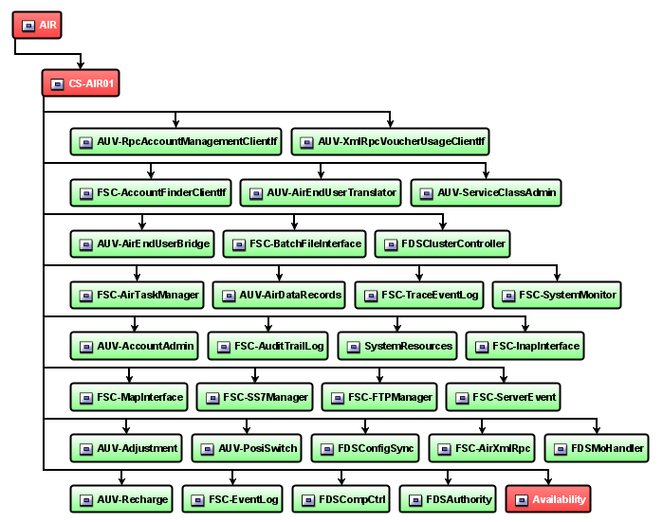
Figure 7 System Topology Example

Integration principles

Service Network Format (SNF)
The SNF MIB is an Ericsson proprietary SNMP MIB describing alarms with corresponding cease messages. It also provides support for stateless events. The alarm list is stored on the managed node making alarm synchronization operations possible for stateful alarms.
OSS Navigator (ESM) has native support for SNF and support alarm list synchronization of nodes implementing the Ericsson SNF MIB.
In case of a heart beat omission or if a restart is detected of the managed node the node is resynchronized.
No network elements in the current solution implements the SNF MIB.

Ericsson IRP (IRP)
The Ericsson IRP MIB is an Ericsson proprietary SNMP MIB describing alarms with corresponding cease messages. It also provides support for stateless events. The alarm list is stored on the managed node making alarm synchronization operations possible for stateful alarms.
OSS Navigator (ESM) has native support for IRP and support alarm list synchronization of nodes implementing the Ericsson IRP MIB.
In case of a heart beat omission or if a restart is detected of the managed node the node is resynchronized.
The Ericsson IRP MIB is applicable for TSP based nodes in the current solution.

Manager Side Translation (MST)
For the OSS Navigator to be able to understand the alarm content from a managed system not using any of the supported SNMP formats the alarm must be translated.
It is possible to receive SNMP traps in raw format or translate based on loading of MIB files, but alarm format will not be consistent and severity is not correctly assigned to the events.
The translations files are developed and placed on the OSS Navigator side to be able to interpret what the managed node is sending. The translation files include the following functionality:
- Alarm/Event Translation
Through correlation it is possible to implement correlated pairs of raise and clear alarms. These are not stateful as MST does not support alarm synchronization of its alarm list.
- Alarm Correlation
Through correlation it is possible to implement correlated pairs of raise and clear alarms. These are not stateful as MST does not support alarm synchronization of its alarm list.
- Alarm Suppressing

This operation is used when there is a need to drop alarms and events that are of non interest to the operator of the implemented service models. Suppressed alarms do not appear in the alarm browser. If an alarm is known to be harmless, there is a possibility to add a suppress statement in the translation file.

In case of a heart beat omission or if a restart is detected of the managed node there is an availability alarm, but resynchronization is not supported.

TXF
TXF based nodes stores their alarms in text files which are uploaded and appended to the alarm reception file(s) in OSS Navigator. The TXF format includes heartbeat messages used to monitor the availability of the managed node.
Alarms and Events using TXF for alarms and events can be synchronized, but initiation must be supported by the managed node.
Most of the managed nodes in the current solution implement the Ericsson TXF format for alarm management.

Fault Management Integration
The following FM integrations are implemented in the delivery per node system type.

Node Type | Number of nodes | FM protocol | Description
AIR | 10 | TXF | Standard integration, covered by CS tech pack
CCN | 14 | SNMP (IRP) | Standard integration, covered by CS tech pack
CRS | 3 | TXF | Standard integration, covered by CS tech pack
IVR/VXML | 6 | SNMP (MST) | Standard integration, covered by CS tech pack
MINSAT | 2 | TXF | Standard integration, covered by CS tech pack
SDP | 34 | TXF | Standard integration, covered by CS tech pack
VS | 2 | TXF | Standard integration, covered by CS tech pack
SunMC | 2 | TXF or SNMP | Customized integration will be developed
HXC | 10 | SNMP (MST) | Customized integration will be developed
EMM FE | 1 | SNMP (MST) | Customized integration will be developed
EMM Online | 1 | SNMP (MST) | Customized integration will be developed
Table 2 Fault Management Integrations

Northbound Interface
It is possible to forward the alarms to the northbound interface from the OSS Navigator with the NMS Alarm Agent. The supported protocol for the northbound interface is BNSI v3 (Basic Network Surveillance Interface) which is a text based protocol.
BNSI v3 supports:
- Alarms are sent in clear text, hence translation maps are not needed.
- Alarm Ack and UnAck of alarms, the time and userid are logged by ESM.
- Alarm Deletion, the alarm is removed from ESM's alarm cache (not from the actual node), that is if the node is synchronized, then the alarm reappears. Time and userid are logged by ESM.
- Synchronization of the entire network or specific network elements in the ESM alarm cache.
Integration of any external NMS, e.g. Netcool, is considered out of scope in this project.

Performance Management
OSS Navigator is responsible of mediation of performance and statistics from all managed nodes in the solution.
The component in OSS Navigator implementing this functionality is named Ericsson Surveillance Manager (ESM). It has support for collection of data from managed nodes as well as processing of data into a common data format based on XML which is being used for loading of the statistics into the PM database in Navigator.

Ericsson Surveillance Manager

Mediation (SFTP)
Processing
Conversion
Network Elements
Raw Data Format
3GPP XML Files
Export Files
KPIs
Figure 8 PM data flow

Another feature of ESM is the ability to use a subset of the collected to present real time KPIs used in the service models in OSS Navigator to monitor service quality and performance.
For a complete list of integrations refer to the tables in chapter Error: Reference source not found.

SNMP Collections
All nodes that have support for statistic counters in their SNMP agents can be polled by SNMS at configurable intervals. The collected data can be used for real time KPIs or be exported to file for loading into a Data Warehouse for presentation using Business Objects reports.
The SNMP collected statistics data can also be exported to XML files for loading into external Data Warehouse, such as Ericsson’s ENIQ.
The current solution does not include any SNMP collections. The nodes in scope of this solution provide required statistics in other formats, i.e. file.
The SNMP framework is however present for future integration possibilities.

Performance and Statistics File Interface
ESM includes a file mediation utility responsible of collecting files including performance and statistics data from nodes using the SFTP protocol. Each collected data file is then related with a processing utility function with the purpose of normalization and formatting of the collected statistics into a common format, i.e. 3GPP XML.
It is also possible to collect the statistics from the local file system in the event of using customized mediators to extract information from the node.

Solution Specific Statistics Interfaces
Some network element types do not have a defined interface for collection of performance and statistics. It is possible to implement node specific integrations for the purpose of extracting this information if the data is available in the system in other formats, such as in database, through commands or using other proprietary protocols.
The solution includes specific mediators for the following node types:
- Ericsson Multi Mediation, File and Event
- Ericsson Multi Mediation, Online Mediation

Real-Time Key Performance Indicator Monitoring
The implementation of Key Performance Indicators (KPIs) is a feature part of the ESM framework. All performance and statistics data that is mediated using ESM functionality are subject to provide the KPI generation with input data for real time publishing in OSS Navigator.
All implemented KPIs are subject to threshold and rating mechanisms and can as such be used to contribute to the state of a delivered service.
The solution includes definitions in order to provide the implemented Service Models with required KPIs. Each managed service includes a maximum of 5 real time KPIs in the model.
The following information in monitored for all servers managed by OSS Navigator if applicable in the managed node:
- CPU Usage
- Memory Usage
- Disk Utilization
In addition to these resource indicators additional KPIs are implemented as part of the service model implementations.

PM Retention times
The data retention specifies how long a data will be kept in the database. Beside raw data, PM system produces summarized and aggregated data that needs to be preserved as well. The reporting system can still use the performance data whenever the data is still in retention period.

Data | Retention time (days) | Description
Raw data | 4 | Number of days that the data is kept at granularity level native.
Hourly data | 10 | Number of days that the data is kept at granularity level hour.
Daily data | 100 | Number of days that the data is kept at granularity level day.
Weekly data | 400 | Number of days that the data is kept at granularity level week.
Monthly data | 400 | Number of days that the data is kept at granularity level month.
Table 3 PM retention times

Performance Management Integrations
The following PM integrations are implemented in the delivery per node system type. I.e. PM data from the following node types will be collected, stored and aggregated in the PM database located in the OSS Navigator.

Node Type | Number of nodes | PM type | Description
AIR | 10 | File based (XML) | Standard integration, covered by CS tech pack
CCN | 14 | File based (XML) | Standard integration, covered by CS tech pack
CRS | 3 | File based (XML) | Standard integration, covered by CS tech pack
IVR/VXML | 6 | File based (XML) | Standard integration, covered by CS tech pack
MINSAT | 2 | File based (XML) | Standard integration, covered by CS tech pack
SDP | 34 | File based (XML) | Standard integration, covered by CS tech pack
VS | 2 | File based (XML) | Standard integration, covered by CS tech pack
EMM FE | 1 | File based (XML) | Customized integration will be developed
EMM Online | 1 | File based (XML) | Customized integration will be developed
Table 4 Performance Management Integrations

Configuration Management
The Configuration Management function makes it possible to configure systems centrally from the OSS Navigator full client.
Configuration operations are registered per object in the logical view and these operations are executed over SSH, HTTPS or HTTP, in order to configure the system.
Operations on the managed network element can be of the type’s script or URL. For scripts, a secure and encrypted link using Secure Shell (SSH) is used and for URLs, a web browser on the SNMS opens with direct access to the defined HTTP link.
Operations and applications can only be accessed using the OSS Navigator full client. The Web Portal of Navigator is restricted to only allow access to Web Based applications.
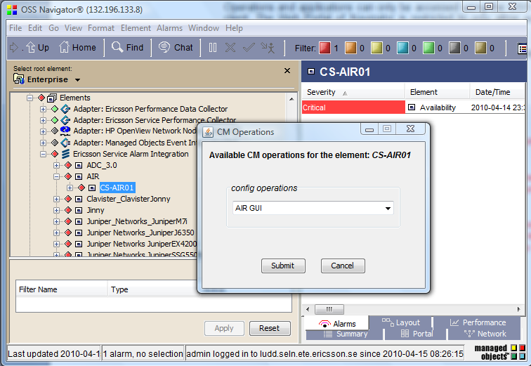
Figure 9 Configuration Management Integration

The following CM operations are implemented in the delivery per system type.

System | Node Type | CM Operation(s) | Description
Charging  System | CCN | Console  Application | Remote access using SSH.  O&M Application
Charging  System | SDP | Console  Application | Remote access using SSH.  O&M Application
Charging  System | AIR | Console  Application | Remote access using SSH.  O&M Application
Charging  System | VS | Console  Application | Remote access using SSH.  O&M Application
Charging  System | VXML_IVR | Console  Application | Remote access using SSH.
Charging  System | MINSAT | Console  Application | Remote access using SSH.  O&M Application
Charging  System | CRS | Console  Application | Remote access using SSH.  O&M Application
Mediation Nodes | EMM Online Mediation | Console | Remote access using SSH.
Mediation Nodes | EMM F&E | Console | Remote access using SSH.
Table 5 Configuration Management Integrations per system type

It is possible to add new operations at any time, and also during runtime, to ease the operator’s daily operations.

Service Level Management
The feature Service Level Management (SLM) provides the possibility to monitor status on the services provided rather than monitoring the individual resources.
The SLM provides capabilities to model and calculate the dependency between end-to-end services, based on collected performance data and alarms. Services are monitored in both a real-time and an SLA perspective, allowing the operator to act before a service becomes unavailable, or before any SLA is violated.
The following features are in the context of SLM and described here:
- Service Modeling
- Service Quality Monitoring (SQM)
- Root Cause Analysis (RCA) & Impact Analysis (IA)

Service Modeling
The Service Models are designed to describe a service as implemented in the network.
To be able to monitor a service the relationship between nodes contributing to the service delivery and ranking of the information provided must be known. The information used is provided from the nodes in the form of alarms and events, but also performance and statistics data is used. The performance data is compiled into a set of service specific Key Performance Indicators where the presented values are compared to threshold definition to determine their actual status. The process of mapping information and relationship and controlling how status is propagates is commonly known as Service Modeling.
The following figure illustrates the logic behind the creation of a service model.
Service
Component
Service
Component
Service
Node alarms and KPIs
Managed
Node
Managed
Node
Managed
Node
Component KPI
Service KPI
Node alarms and KPIs
Node alarms and KPIs
Figure 10 Principle of Service Modelling
In the example above the service is based on two service components, each representing functionality required by the service, and one service level KPIs. The service components are based on information from the nodes such as alarms and KPIs, but may also use KPIs reflecting the functionality. In case of redundancy this is also built into the service component, like in the left part.
Ericsson will deliver the standard Ericsson Charging System service model as part of the solution delivery. The following services are modeled in the standard CS Tech Pack:

- CDR Handling
  - CDR generation
  - CDR Processing
- Charging Services
  - Content charging
  - Voice charging
  - SMS Charging
- User Services
  - Enquiry
  - Refill
  - Account Update
- Provisioning Services
  - Subscriber Provisioning

Service Quality Monitoring
All modeled services are represented using states indicating the current status of the service delivered. The service state is presented in real time, but it is also possible to apply Data Warehouse profiles to the service objects making it possible to present the service state as it has performed over time.
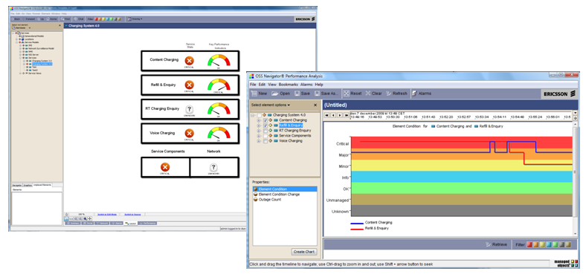
Figure 11 Service Quality Monitoring Navigator Client

Root Cause Analysis and Impact Analysis
SLM provides the ability to determine the root cause of a service failure as well as the impact of an element failure and what service(s) is/are impacted by that failure.
The Root Cause Analysis function of the SLM feature provides a quick way to identify the lower level object that caused a change in the condition of a higher level service object.
The Impact Analysis function lets you quickly identify all the higher level objects that are affected by the condition change of the selected object.
All services defined in the provided Service Models will benefit from the possibility of RCA/IA.

MyNavigator
Service status can also be monitored using the MyNavigator web portal. The web portal can be customized to present individual pages to different user categories presenting both service status and Key Performance Indicators.
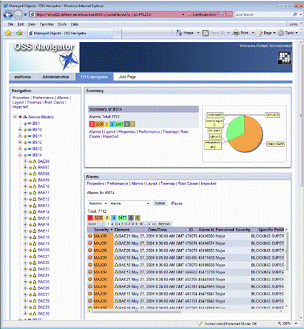
Figure 12 Monitoring using MyNavigator Portal
The solution includes the configuration of one user specific portal view presenting service quality information. MyNavigator is fully configurable to present information implemented in the Service Models and additional views can easily be configured by the system administrator.

Performance Reports, Business Objects
The historical PM reporting solution is based on the Business Objects Enterprise XI 3. The PM data is retrieved from the managed nodes and stored in the Sybase statistical database in the OSS Navigator.
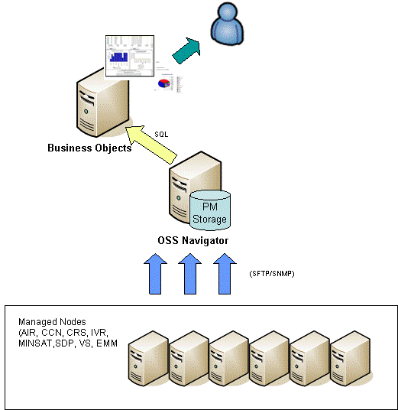
Figure 13 PM (historical) solution
Customized Business Objects reports will be developed to present the data. The reports that are delivered are listed in the following chapters.

Measurements and counters
OSS Navigator will be pre-configured to fetch certain performance counter measurements that are available on the Charging nodes. Additional counters can be configured for loading into OSS Navigator if needed. The counters that are available in the Charging nodes are explained in the corresponding Charging node CPI (Customer Product Information). It shall be noted that the CAPv1 counters will represent SMS + Data charging cumulative requests whereas CAPv2 counters will represent Voice calls.
Based on the pre-defined counters there will be a set of customized reports for Business Objects developed. There reports are described in chapter 6.8.2. Please note that the reports that include Diameter counters (CCN Diameter Access Report and CCN Success Rate) will not be available unless the Diameter is taken into use in the network.
It shall be noted as well that there is CDR specific data which is not loaded into the OSS Navigator as this is taken care of by the CRS node. Please refer to the CRS documentation for details.

Customized reports

Platform Performance Report
The BO Report will display status report for each of these nodes (CCN, AIR, SDP, IVR, EMM FE/Online, MINSAT and CSR). The report will be displayed based on CPU load, disk usage and memory usage. The data collection for each of these counters is 60 minutes / hourly basis.

Name | Platform Performance Report
Source Node | AIR, CCN, CSR, EMM, IVR, MINSAT, SDP
Source Type | File
Interval | Daily
Retention | Week to day
X-Axis | Date
Y-Axis | CPU Load and Memory Usage (%)
Formula | Daily average for CPU load and memory usage
Note | -
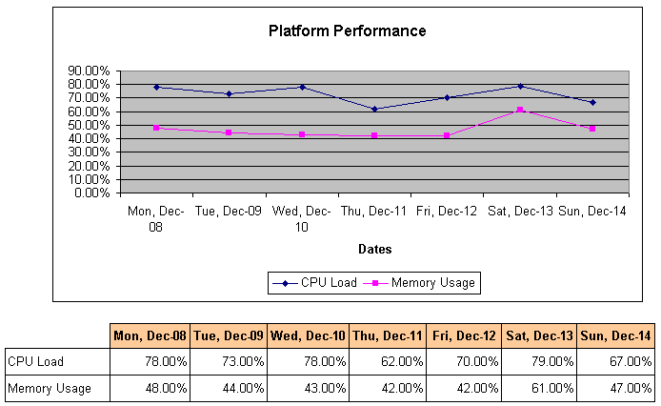
Figure 14 Platform Perofmance Report

CCN BHCA Report
The BO Report will create summary report and detailed node report for CCN BHCA. The summary report will display all CCN nodes in a single graph. The detailed report will display each of CCN nodes based on selection. The report is formulated based on below definition.

Name | CCN BHCA Report
Source Node | CCN
Source Type | File
Interval | Daily
Retention | Week to day
X-Axis | Date
Y-Axis | BHCA
Formula | BHCA = RelayContent-FirstInterrogation-Successful + RelayContent-FirstInterrogation-InternalError + RelayContent-FirstInterrogation-NoContactWithSDP + RelayContent-FirstInterrogation-Congestion
Note
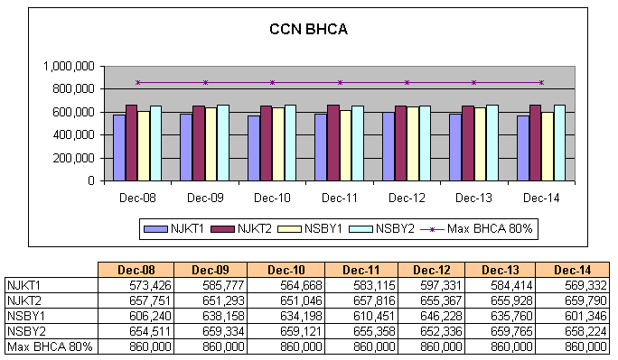
Figure 15 CCN BHCA Report

CCN Diameter Access Report
The BO Report will show a detailed node report for each of CCN diameter access based on client ID.

Name | CCN Diameter Access Report
Source Node | CCN
Source Type | File
Interval | Daily
Retention | Week to day
X-Axis | Date
Y-Axis | Attempts
Formula | Attempts = Total of DiamAccess-AppReqReceived-<connId>-<appName> counters
Note | -

CCN INAP Utilization Report
The BO Report will create summary report and detailed node report for CCN INAP utilization. The summary report will display all CCN nodes in a single graph. The detailed report will display each of CCN nodes based on selection.
Name | CCN INAP Utilization Report
Source Node | CCN
Source Type | File
Interval | Daily
Retention | Week to day
X-Axis | Date
Y-Axis | Utilization (%)
Formula | Utilization = Charging Result / Charging Request * 100%  Charging Result = Total of (InapSdf-SDP-<sdp-ID>-TotalResults – InapSdf-SDP-<sdp-ID>-FailedResults)  Charging Request = Total of InapSdf-SDP<sdp-ID>-TotalRequests
Note | -
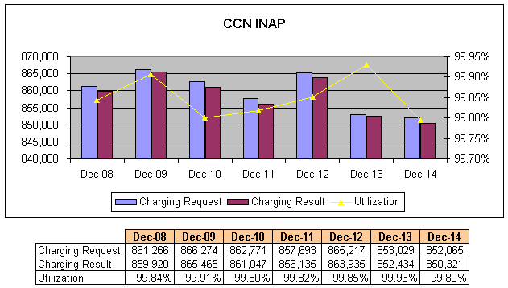
Figure 16 CCN INAP Utilization Report

CCN CDR Report
The BO Report will create summary report and detailed node report for CCN CDR Report. The summary report will display all CCN nodes in a single graph. The detailed report will display each of CCN nodes based on selection.

Name | CCN CDR Report
Source Node | CCN
Source Type | File
Interval | Daily
Retention | Week to day
X-Axis | Date
Y-Axis | Successful, Total and Success Rate
Formula | Success Rate = CdrOutput-Encoded-Successful / (CdrOutput-Encoded-Successful + CdrOutput-Encoded-Failed) * 100%
Note | -
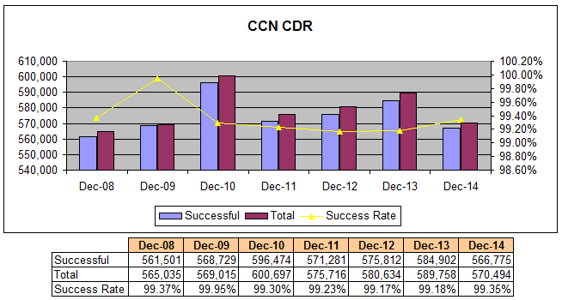
Figure 17 CCN CDR Report

AIR Utilization Report
The BO Report will create summary report and detailed node report for AIR utilization. The summary report will display all AIR nodes in a single graph. The detailed report will display each of AIR nodes based on selection.
Name | AIR Utilization Report
Source Node | AIR
Source Type | File
Interval | Daily
Retention | Week to day
X-Axis | Date
Y-Axis | Utilization (%)
Formula | Utilization = Response / Attempt * 100%  Response = AIR_FSC_MapInterface_counterSet :: ETSI MAP Response V2 + AIR_FSC_AirXmlRpc_counterSet :: Response  Attempt = AIR_FSC_MapInterface_counterSet :: ETSI MAP Request V2 + AIR_FSC_AirXmlRpc_counterSet :: Request
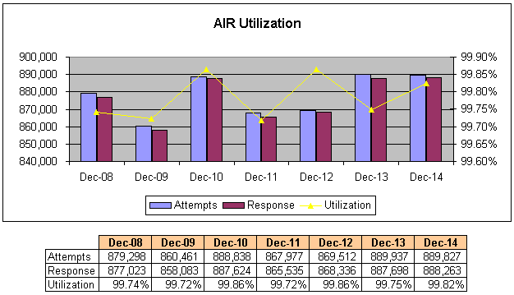
Figure 18 AIR Utilization Report

AIR BHCA Report
The BO Report will create summary report and detailed node report for AIR BHCA. The summary report will display all AIR nodes in a single graph.

Name | AIR BHCA Report
Source Node | AIR
Source Type | File
Interval | Daily
Retention | Week to day
X-Axis | Date
Y-Axis | BHCA
Formula | BHCA = AIR_FSC_MapInterface_counterSet :: ETSI MAP Request V2 + AIR_FSC_AirXmlRpc_counterSet :: Request
Note | -
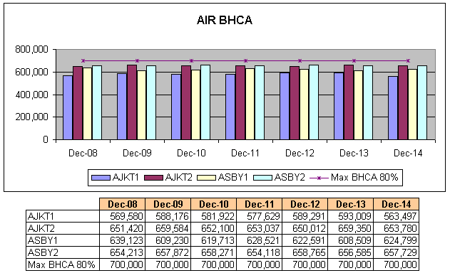
Figure 19 AIR BHCA Report

SDP BHCA Report
The BO Report will create summary report and detailed node report for SDP BHCA. The summary report will display all SDP nodes in a single graph based on selection. The detailed report will display each of SDP nodes based on selection.

Name | SDP BHCA Report
Source Node | SDP
Source Type | File
Interval | Daily
Retention | Week to day
X-Axis | Date
Y-Axis | BHCA
Formula | BHCA = Originating attempts + Terminating attempts + Roaming originating attempts + Roaming terminating attempts + Call back attempts
Note | Counters located in SDP_PSC_TrafficHandler_Service_counterSet by default
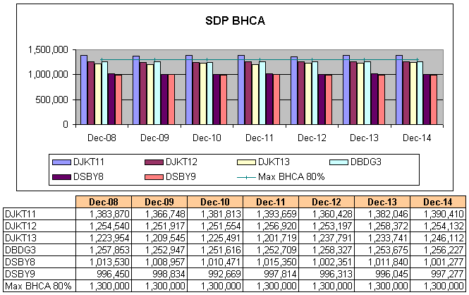
Figure 20 SDP BHCA Report

CCN Success Rate

Name | CCN Success Rate
Source Node | CCN
Source Type | File
Interval | Daily
Retention | Week to day
X-Axis | Date
Y-Axis | Success Rate (%), Request and Response
Formula | Diameter Access:  Success Rate = Diameter Response / Diameter Request * 100%  Diameter Response = Total of DiamAccess-AppReqAnswered-<connId>-<appName> counters  Diameter Request = Total of DiamAccess-AppReqReceived-<connId>-<appName> counters  INAP:  Success Rate = Charging Result / Charging Request * 100%  Charging Result = Total of (InapSdf-SDP-<sdp-ID>-TotalResults – InapSdf-SDP-<sdp-ID>-FailedResults)  Charging Request = Total of InapSdf-SDP<sdp-ID>-TotalRequests
Note | The report is displayed per node
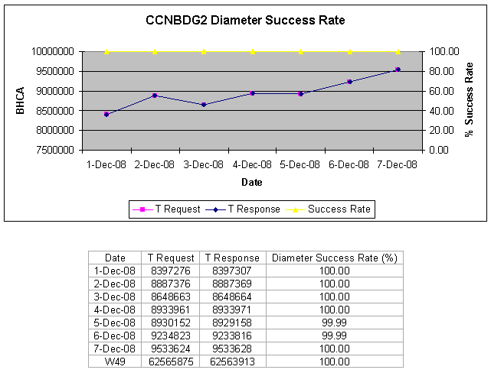
Figure 21 CCN Success Rate Report

BHCA Load Report

Name | BHCA Load Report
Source Node | AIR, CCN, SCP, SDP
Source Type | File
Interval | Daily
Retention | Week to day
X-Axis | Date
Y-Axis | BHCA
Formula | AIR: BHCA = AIR_FSC_MapInterface_counterSet :: ETSI MAP Request V2 + AIR_FSC_AirXmlRpc_counterSet :: Request  CCN: BHCA = RelayContent-FirstInterrogation-Successful + RelayContent-FirstInterrogation-InternalError + RelayContent-FirstInterrogation-NoContactWithSDP + RelayContent-FirstInterrogation-Congestion  SDP: BHCA = Originating attempts + Terminating attempts + Roaming originating attempts + Roaming terminating attempts + Call back attempts
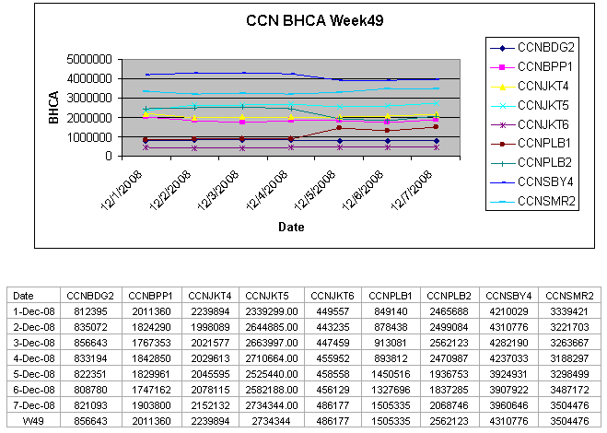
Figure 22 BHCA Load Report

References

- OSS Navigator Product Description, 1/221 01-FGC 101 0382 Uen Rev E
- OSS Navigator 1.2 Feature Description - Basic features, 4/221 04-FGC 101 0382 Uen Rev D
- OSS Navigator 1.2 Feature Description - Optional features, 5/221 04-FGC 101 0382 Uen Rev F
- System Administrator Guide, 1543-2/AOM 901 052 Uen AD3
- FACILITY DESCRIPTION, 155 34-2/AOM 901 052 Uen N

